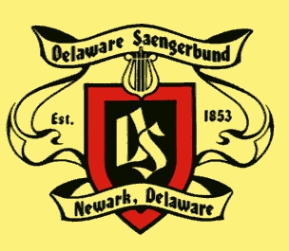
DEUTSCHE SCHULE IM DELAWARE SAENGERBUND
2025 - 2026
APPLICATION DEADLINE – SEPTEMBER 24, 2025

The Deutsche Schule at the Delaware Saengerbund is preparing for the new school year with an outstanding team. Richard Grieb serves as Director of the school. All questions are to be directed to him at 610-388-1447 or rgrieb08@aol.com.

Members are invited to sign up their children/grandchildren as soon as possible, as the first 15 will be accepted into each level. The school is open to non-members who are interested in the German language, culture, and heritage. THERE IS NO SCHOOL FEE FOR MEMBERS. THE NON-MEMBER FEE IS $150.00 PER STUDENT.
Classes will be held on Sundays, beginning September 28, 2025, until May 3, 2026. Class time: 1 – 3 p.m. for all classes. Please complete and submit the application form, include a check made payable to the DSB in the amount of $150 if you are a non-member. Mail completed form and check (if applicable) to: Delaware Saengerbund, Attn: Richard Grieb, 49 Salem Church Road, Newark, DE 19713.

Deutsche Schule Application

NAME: _______________________________________________________________________________

ADDRESS:____________________________________________________________________________

PHONE #:_____________________EMERGENCY #:____________________EMAIL:___________

NAME AND AGE OF CHILD:_________________________________________________________

DSB MEMBER:_____________YES________________NO_______________

